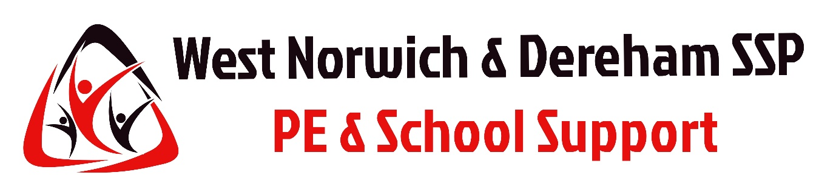

Safeguarding and Protecting Children
WNDSSP EVENTS

The West Norwich & Dereham School Sport Partnership (WNDSSP) are committed to implementing the NSPCC Child Protection in Sport Unit (CPSU) ‘Standards for Safeguarding Children and Young People in Sport’. The Standards reflect the statutory requirements that legislation and guidance places upon the sports sector. In addition, WNDSSP adheres to the Taverham High School Safeguarding policies and support information.

The safeguarding principles adopted by all partners reflect ‘the welfare of the child being paramount’ meaning our priority is to ensure the child’s health and well-being. All children whatever their age, gender culture, language, racial origin, religious beliefs, sexual identity, ability or disability, have equal rights to be safeguarded and protected.

The information & guidance you receive is designed to help create as safe an environment as possible for children & yourself when at WNDSSP events.

Photography / Filming

Photo’s will be taken by WNDSSP staff for use on social media, website & other marketing purposes. If a Child is unable or not permitted to have their Photo taken please ensure WNDSSP staff are made aware of this on your arrival at the event. These students will then be asked to wear a coloured bracelet to identify them throughout the day & ensure they are not photographed at any time.

Please ensure this bracelet is then returned to WNDSSP on your departure.

Behaviour

WNDSSP Staff will help to create a fun and inclusive atmosphere at all events. If a child is behaving badly, it is not the WNDSSP’s staff member’s role to discipline them. In creating a fun and inclusive atmosphere, we find that most potential bad behaviour is prevented.

Culture and Religion

Be aware that children will be from different backgrounds with varying faiths, beliefs and practices. It is vital that all Teachers & School Staff are respectful and aware of all cultures.

First Aid Provision

WNDSSP will ensure all event staff involved are suitably qualified with up-to-date First Aid training and basic First Aid resources will be available on site / at the venue. However, it is expected that all Schools will bring their own First Aid resources to cover their Children.

It is the responsibility of the individual school attending to ensure that their staff who accompany their children retain duty of care for them at the event and provide First Aid support as required. WNDSSP events are too large to allow our staff to provide all First Aid support, although we will be there for assistance where possible.

Individual schools retain duty of care for all young people attending West Norwich & Dereham School Sports Partnership events. WNDSSP staff are on hand to provide support but do not & will not take duty of care of an individual school / students.

Roles and Responsibilities in relation to Safeguarding at WNDSSP events

SSP Competitions and Festivals Lead

- Ensure that all safeguarding standards are met.

- Familiarisation with young people’s needs and requirements pre-event.

- Brief all staff before the event regarding safeguarding arrangements including accidents, incidents, medical issue procedures which they must follow if emergency aid is required.

- Liaise with the venue regarding security and weather arrangements

- Liaise with the venue regarding dietary matters (if relevant).

- Ensure the event meets health and safety requirements and associated standards and that the event is accessible for all young people.

- Be clearly identifiable whilst on duty.

- Be observant and diligent at all times, ensuring that the young people are having a positive experience.

Teachers & other School Staff (from individual schools attending SSP events)
If YP not found event dir to contact teacher and local police may be contacted.

- Before arriving, ensure that all relevant e-mails and event information sent by the organiser has been read and understood.

- Ensure that their students have been thoroughly prepared and are fully aware of the objectives of the opportunity and what is expected of them.

- Be responsible for the students during their Transport to and from the event and adhere to the timings / guidance provided the by the event organiser in regard to the event transport.

- All staff attending SSP events on behalf of individual schools should have Enhanced DBS checks in place & have undergone all relevant & appropriate safeguarding checks / training. This will then allow them to be in a position to supervise their children at the event and to be part of a larger scale event involving numerous schools.

- Information required from teachers:

  - Permission for the taking of photographs and visual footage or ensuring the event organiser is aware if there is a restriction on their child’s image being taken or used.

  - Details of any specialist medical needs/allergies (retained by teacher)

  - Where a young person is disabled, provide information relating to any additional needs.

  - Where a young person is taking regular medication, teachers should ensure that their young person carries enough medication for the duration of the event and that the Event organiser is informed.

  - Details of any specific dietary needs (if relevant)

  - Details relating to any additional educational support needs.

  - Any other information that supports their student’s maximisation of opportunity at the Event.

- Ensure that young people from their school are respectful of rules, the impact of their behaviour on others and instructions provided by SSP staff.

Signed on behalf of the WNDSSP __________________________ Name: Matthew Mann
Date:
Signed on behalf of school: _________________________ Name: _____________________
Date

