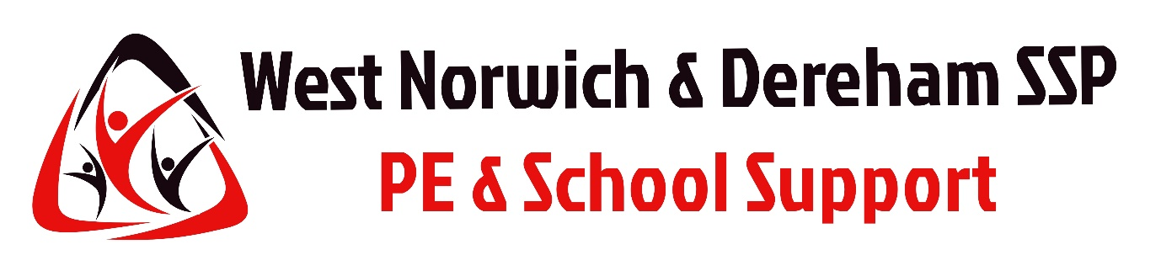

Event / Festival / Competition Code of Conduct

All attending Parents / Carers / Spectators / Staff at WNDSSP events must set an example for the young people participating by demonstrating the highest standards of sporting behaviour. These events are for young people and their participation & enjoyment is the most important element of the day

We encourage and remind all Parents / Carers / Spectators / Staff to:

- Always approach the event organiser in the first instance with any issue or concern. Please do not approach Sports Leaders with any concerns

- Encourage your child / pupils / team to learn the rules & play within them

- Discourage unfair play & do not let Children argue with the officials

- Set a good example by recognising fair play & applauding good performances

- Respect the official’s decision, especially if those officials are young Sport Leaders. These young leaders have kindly given up their time to volunteer at today’s event - without their help these events would simply not happen

- Give encouragement to everyone who is participating

- Use correct & proper language at all times and refrain from shouting / screaming at any participants or Leaders

- No photos are to be taken by parents / carers at WNDSSP events. Only School staff have permission to take pictures of the children (if correct permissions have been granted by their parents)

