Welcome to the West Norwich & Dereham 5 Ways to Wellbeing Challenge.
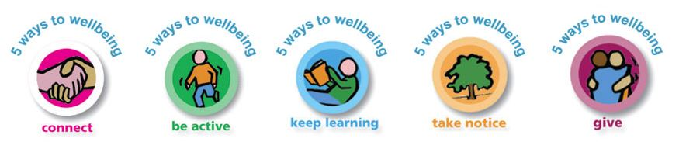
Your challenge is to complete as many of the tasks below as you can before Monday 22 February
Anyone completing 3 out of 5 of EACH challenge will receive a BRONZE AWARD, complete 4/5 for a SILVER AWARD and complete ALL Challenges for GOLD
EYFS / KEY STAGE  1 | 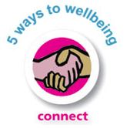 | 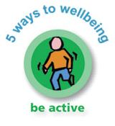 | 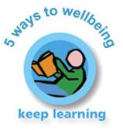 | 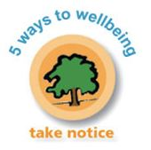 | 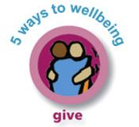
1 | Have a ‘smiling’ challenge with someone at home *  Complete? | Build a den safely  *  Complete? | Learn to tie your shoelaces  Complete? | Do some mindful colouring *  Complete? | Make someone smile by saying something nice to them every day for a week!  Complete?
2 | Sit with someone and listen to a new piece of music, talk about it, did you both like it? What did you like or not and why?  Complete? | Shopping bag race (like a sack race but with a sturdy shopping bag)  Complete? | Find out something interesting about someone in your family and write it down  Complete? | Watch the clouds, what shapes can you see? Can you draw something using the shapes for ideas?  Complete? | Look through your toys & books, can you give any to charity that you don’t need or use anymore?  Complete?
3 | Practice your ‘5 deep breaths’ everyday when you get up *  Complete? | Do an Indoor Scavenger Hunt *  Complete? | Make a bubble mixture and blow bubbles outside *  Complete? | Can you draw a face with your eyes closed? Stop and think carefully.  Complete? | Be more environment aware- Turn off lights / pick up litter / recycle)  Complete?
4 | Send a card, letter, drawing or some jokes to a local care home.  Complete? | Put on your favourite song and dance for the WHOLE song!  Complete? | Find out about the season, can you think of something to Plant and grow?  Complete? | Play the ‘memory game’*  Complete? | Give your eyes a break from your screen devices and hour before bed for 5 days!  Complete?
5 | Tell someone a joke to make them laugh  Complete? | Hand-Foot Coordination challenge activity *  Complete? | Ask a grown up to help you learn how to make a healthy snack  Complete | Go for a walk and use your senses (See / Smell / Feel / Hear)  Complete? | Do something to help someone (carry something/tidy up / clean the garden)  Complete?
ADD YOUR OWN CHALLENGE | Complete? | Complete? | Complete? | Complete? | Complete?
*Indicates there is an extra information sheet available for this task.

