Welcome to the West Norwich & Dereham 5 Ways to Wellbeing Challenge.
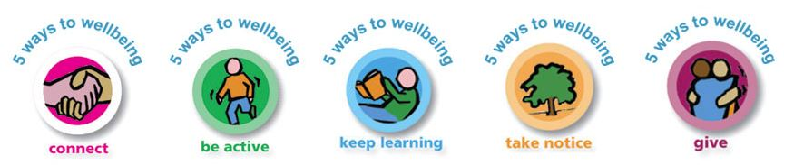
Your challenge is to complete as many of the tasks below as you can before Monday 22 February
Anyone completing 3 out of 5 of EACH challenge will receive a BRONZE AWARD, complete 4/5 for a SILVER AWARD and complete ALL Challenges for GOLD
EYFS / KEY STAGE  2 | 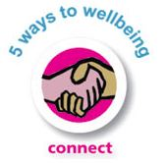 | 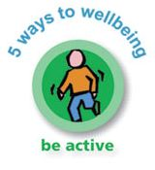 | 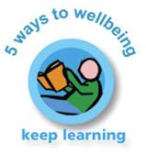 | 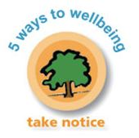 | 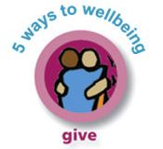
1 | Have a ‘smiling’ challenge with someone at home *  Complete? | Do an Indoor Scavenger Hunt *  Complete? | Make a healthy snack – find out WHY it is healthier.  Complete? | Play the ‘memory game’*  Complete? | Make someone smile by giving a compliment every day for a week!  Complete ?
2 | Sit with someone and listen to a new piece of music, talk about it, did you both like it? What did you like or not and why? How did it make you feel?  Complete? | Go outside and blow bubbles (washing up liquid/water – make a blower out of pipe cleaner, top of a bottle/ cardboard tube.*  Complete? | Learn to say ‘Good morning, good night, please & thank you’ in another language and use it every day for 5 days.  Complete? | Watch the clouds, what shapes can you see? Can you draw something using the shapes for ideas?  Complete? | Look through your toys & books, can you give any to charity that you do not need or use anymore?  Complete?
3 D | Connect with yourself - Practice your ‘5 deep breaths’ everyday when you get up*  Complete? | Try and juggle with rolled up socks/balls. Try 2, 3 or 4 at the same time  Complete? | Find out something interesting about the local area you live in and write it down.  Complete? | Can you draw a face with your eyes closed? Stop and think really carefully.  Complete? | Be more environment aware- Turn off lights / pick up litter / recycle)  Complete?
4 | Send a card, letter, drawing or some jokes to a local care home.  Complete? | Put on your favourite song and dance for the WHOLE song!  Complete? | Listen to a style of music you might not have heard before, what is it called.  Complete? | Do some mindful colouring-how do you feel while drawing? Calmer/ more relaxed?  Complete? | Give your eyes a break from your screen devices and hour before bed for 5 days!  Complete?
5 | Phone a relative / friend you haven’t seen for while to check up on them – No texting  Complete? | Build a den safely, inside (use blankets/ sheets/chairs) or outside (use washing line to hang sheet on *  Complete? | Ask a grown up to help you learn how to make a healthy snack  Complete | Complete a wellbeing wordsearch *  Complete? | Do something to help someone (carry something/tidy up / clean the garden)  Complete?
ADD YOUR OWN CHALLENGE | Complete? | Complete? | Complete? | Complete? | Complete?
*Indicates there is an extra information sheet available for this task.

